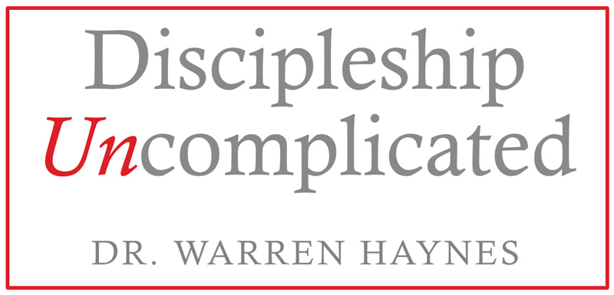
Step by Step
Guide to Getting the More Out of Your
Discipleship Uncomplicated Event
Step 1: Choose the type of event that works best for you
- Keynote special event speaker/preacher
- 2-hour overview conference
- 2-day conference
- Overnight Retreat
- Weekend Focus (Friday evening, Saturday, Sunday)
- Sunday Morning & Evening
- Sunday Morning Single Inspirational Message
- Event Breakout Session Leader
- Other: ________________________________
Step 2: Set location, dates, & time
- Name: _______________________________________________________
- Location: _____________________________________________________
- Dates: _______________________________________________________
- Times: _______________________________________________________
- Best Contact number: ___________________________________________
Step 3: Enlist people to PRAY for this event and start believing GOD for great things!
Step 4: Create an event reach list
- Create a complete list of names and contact information. The two most important pieces of information are their NAMES and HOW TO CONTACT them.
- Include Essential information: Names, email, phone number, and Social Media Information: Facebook, twitter, LinkedIn
- How many people are on your reach list? ___________
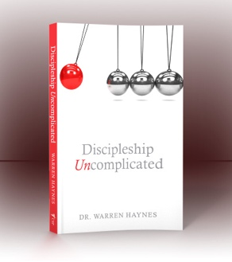
Step 5: Pre-order Discipleship Uncomplicated books
- Pre-order Books at www.warrenTALKS.com You will not be charged for books you do not use. Put this book in the hands of your leaders and key people and encourage them to generate interest in the groups they lead.
- Plan to order 2 books for every participant and 4 books for every leader. #____x2 = ____ + #____x4=________
- How many books do you need to order? __________ (total)
Step 6: Start promoting and keep promoting
- Personal Invitation (Coach every leader to personally invite 3 people using these words, “I want you to come to this event with me?” Nothing beats a personal invitation!
- Your Website _________________________________
- Your Facebook page ___________________________
- Your Twitter __________________________________
- Your Email ___________________________________
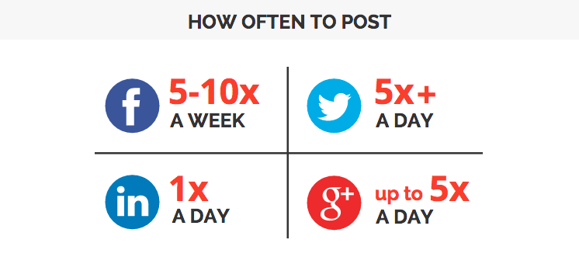
- Invite Cards
- Hand written cards
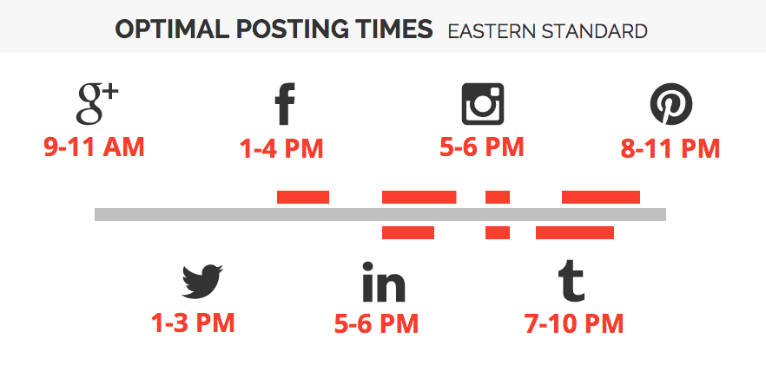
- Phone calls
- Announcements
- Bulletin inserts
- Flyers
Step 7: Prepare facilities for the event
- Seating
- Greet guests
- Gift, Program,
- Food
- Audio Visual
- Volunteers
- Materials

Step 8: Send this completed guide to whhaynes@gmail.com

