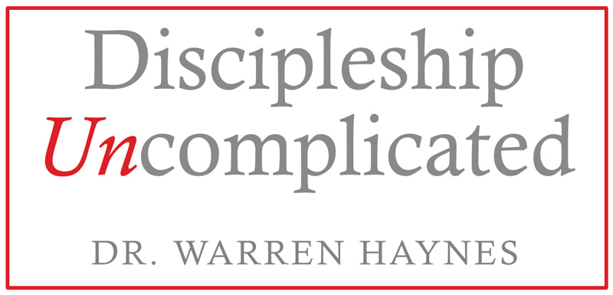
“8 Things you miss if you’re not at this event”

Here are eight powerful principles and practices that will expand your disciple making capacity:

- Discover the heart of making disciples
- How to pinpoint the people you are most likely to influence
- How to bring spiritual power into your personal relationships
- How to create relational breakthroughs
- How to build strong relational connections
- How to move people spiritually
- How to gather and influence people to follow Jesus
- How to multiply leaders and reach new people

In Discipleship Uncomplicated I promises to share with you in understandable terms what you have to do to make disciples. Whether you are an introverted wallflower or an over-the-top people person, Discipleship Uncomplicated delivers exactly what you need to start influencing people for Jesus in a fun, informative, and Scripture-driven experience. I am looking forward to getting to know you.

